Bio: An artist that is currently in BG3 and Chiikawa addiction phase. Saya suka lukis Astarion dengan Usagi setiap 2 hari. Kalau ada duit lebih order sticker custom kat Shopee, kalau ada extra lagi order custom keychain. Dreams to open an artbooth at any ACG conventions.

Instagram: azraellite

Email: [azrin.haffid11@gmail.com](mailto:azrin.haffid11@gmail.com)

Quote: Una YAHA YAHA Una, prri- Usagi

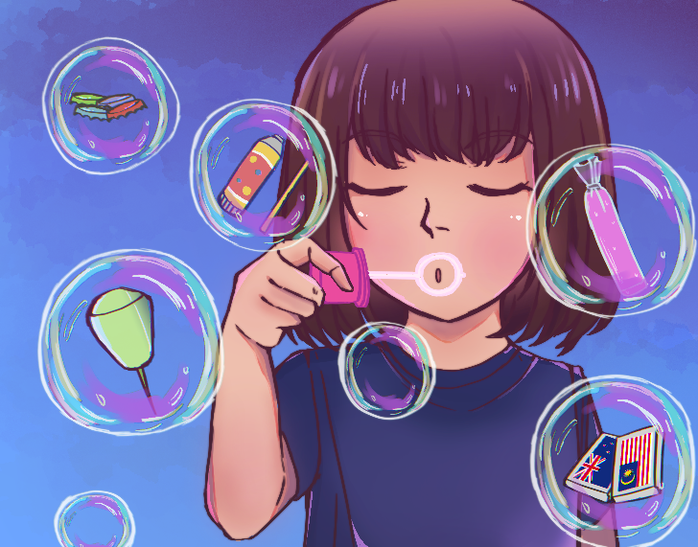

Name: buih buih kehidupan

Desc: Original art made for illustration class assignment

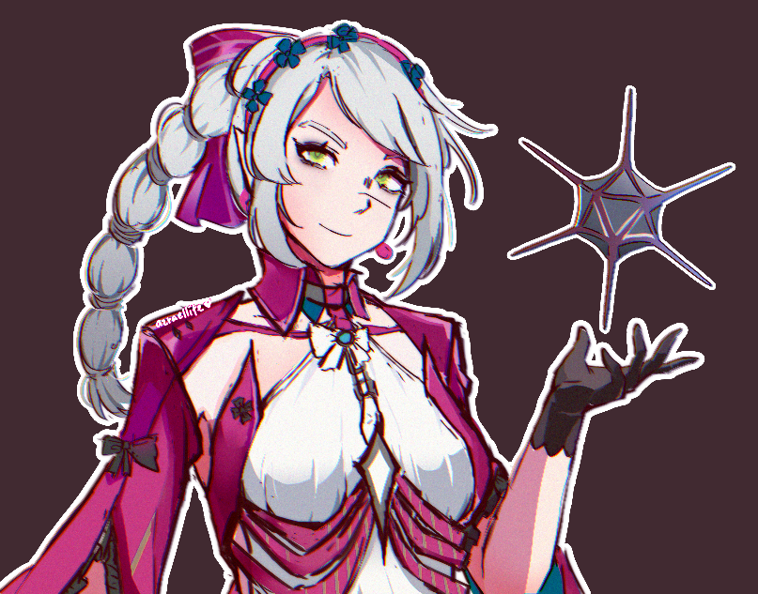

Name: Carlotta Shadowheart (landscape)(1)

Desc: Fanart

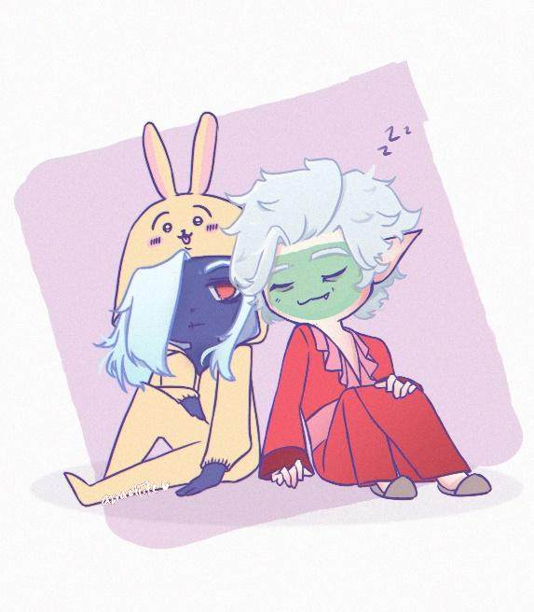

Name: eepy

Desc: I think they’re very cute in their nightwear.

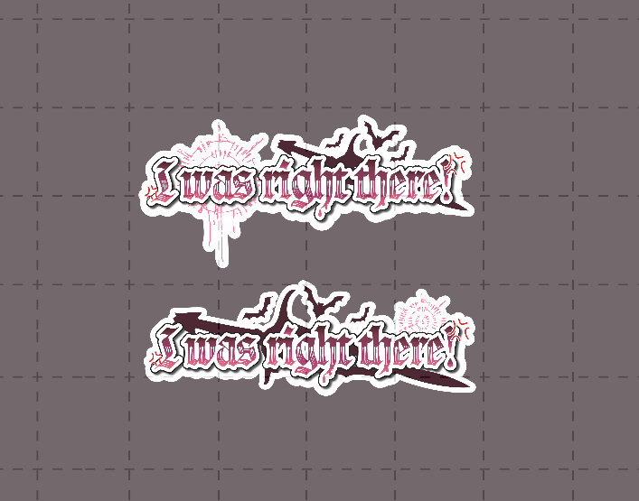

Name: Vtuber logo design style

Desc: I can do graphic design too! Decided to turn a quote into a “vtuber logo” style

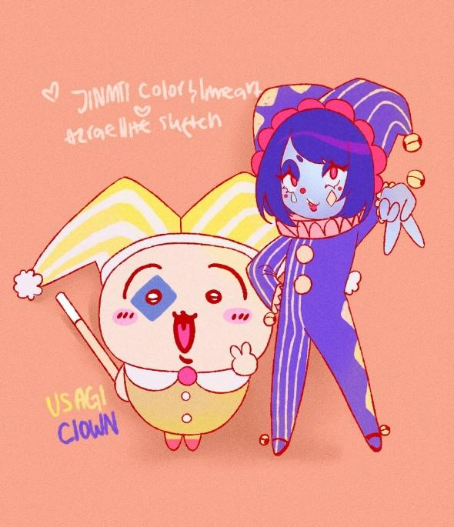

Name: Usagi and clown

Desc: Sketched by me, lineart and colour by nik. Usagi looks very cute in the clown outfit and I think it’s appropriate to draw them together.

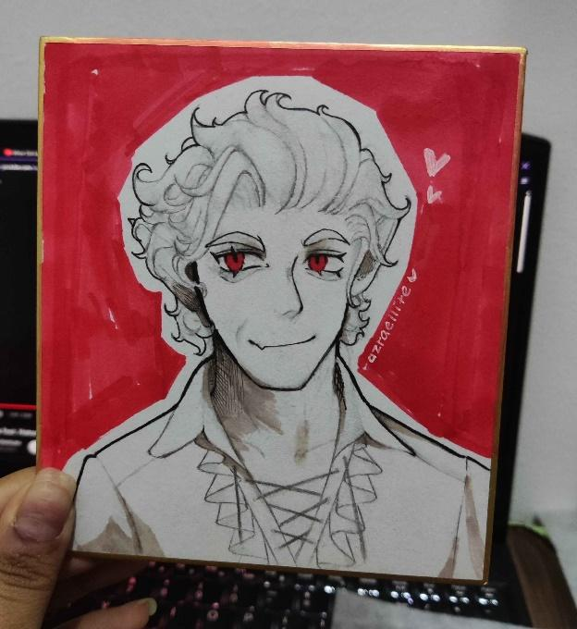

Name: Shikishi Astarion

Desc: Initially made it for myself, ended up given to a “special someone”.

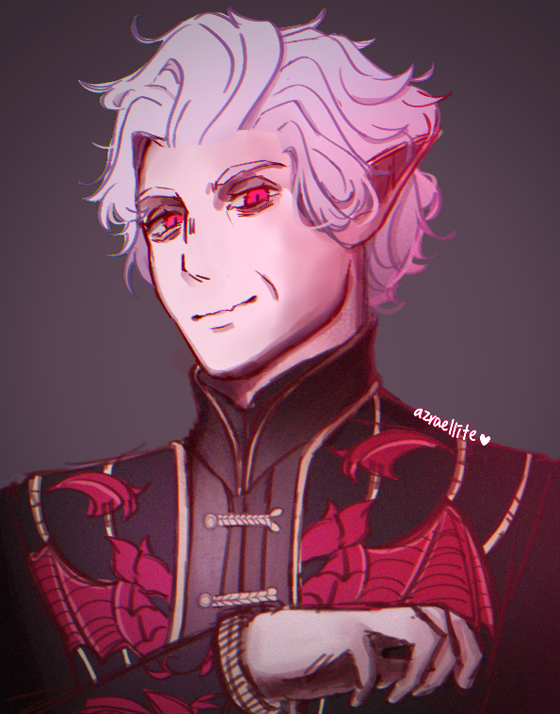

Name: Ascended Astarion (best)

Desc: Fanart, drawn for artprint and photocards